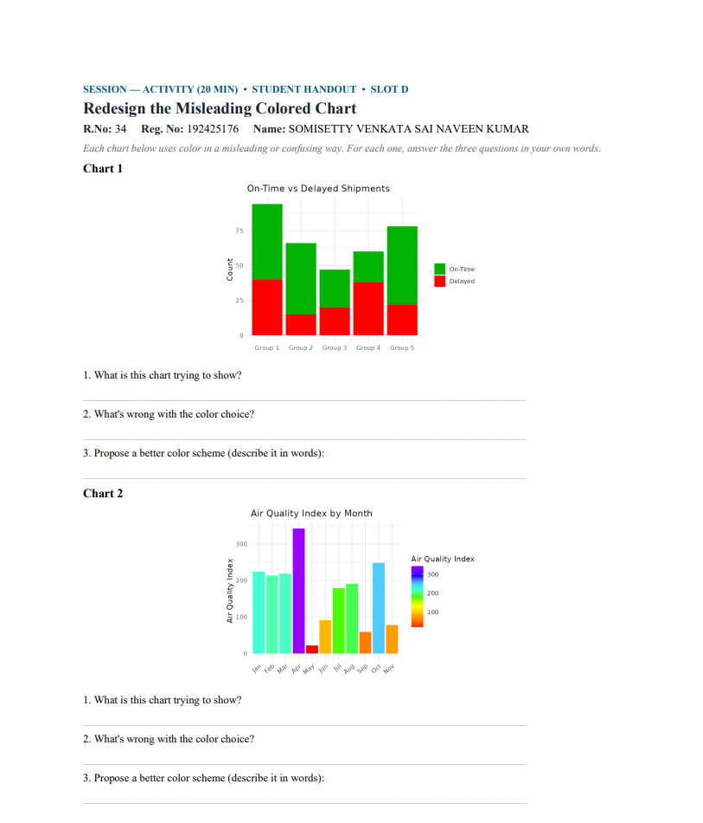
Chart 1 – On-Time vs Delayed Shipments
1. What is this chart trying to show?
It shows the number of on-time and delayed shipments in each group.
2. What's wrong with the color choice?
The chart uses red and green, which can be difficult for people with red-green color blindness to distinguish.
3. Propose a better color scheme:
Use blue for on-time and orange for delayed shipments. You can also add clear labels so the information does not depend only on color.

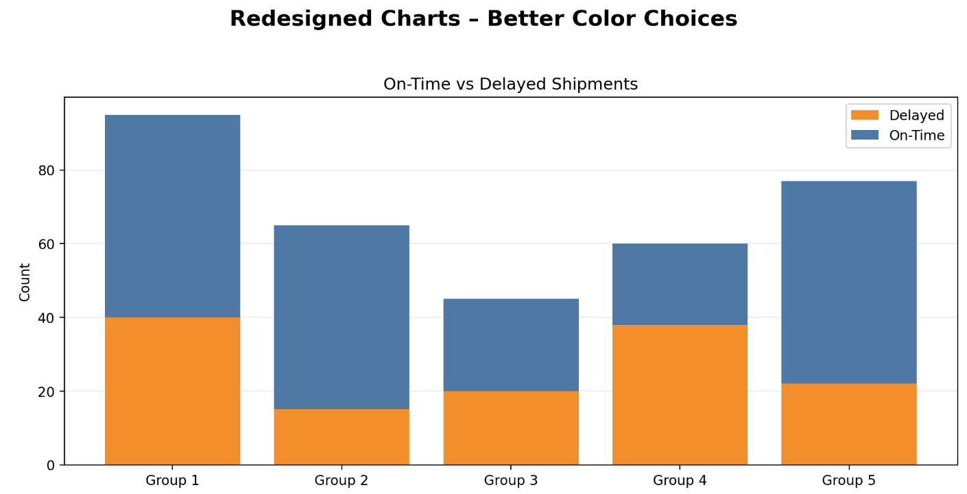

Chart 2 – Air Quality Index by Month
1. What is this chart trying to show?
It shows the Air Quality Index (AQI) for each month and how the air quality changes throughout the year.
2. What's wrong with the color choice?
It uses a rainbow color scale. Rainbow colors do not have a clear natural low-to-high order, so it is difficult to tell which color represents a lower or higher AQI.
3. Propose a better color scheme:
Use a sequential color scale, such as light blue to dark blue, where lighter colors represent lower AQI and darker colors represent higher AQI.
